
East West University

Project Report
Semester: Summer-2025
Course Title: Electronic Circuits Course Code: CSE251
Section: 04

Project Name: Design and Implementation of an Op-Amp Based Precision DC Voltage Amplifier.

Submitted by-
Group No: 06
Group Members:
Student Name | Student Id
Md. Hasib Ali | 2023-3-60-186
Arijit Kumar Anoy | 2023-3-60-055
Md. Shakib Al Hasan | 2024-1-60-200
Fahim Shahriar | 2023-2-60-094
Morshedul Islam | 2023-2-60-125

Submitted to-
Dr. Sarwar Jahan
Associate Professor
Department of Computer Science & Engineering
East West University

Date of Submission: 01 September, 2025
Title: Design and implementation of an Op-Amp Based Precision DC Voltage Amplifier.

Abstract

This project involves the design, simulation, and construction of a high-precision DC voltage amplifier. The amplifier’s performance was tested in terms of gain accuracy and its stability across temperature variations.

Introduction
An operational amplifier (op-amp) is an electronic device with a high gain that amplifies the voltage difference between two input terminals. It serves as a fundamental component in many analog circuits due to its versatility. Op-amps generally feature two high-impedance inputs and a low-impedance output. A precision DC voltage amplifier is specifically designed to amplify low-level DC signals with high accuracy, reducing noise and distortion. In this project, the op-amp is set up to provide a fixed gain, and its performance is tested through both computer simulation and hands-on measurements using precision resistors.

Objectives
1. To design a precision DC voltage amplifier circuit using an operational amplifier configured for a fixed voltage gain.
2. To calculate the required resistor values to achieve the desired gain, and choose suitable components accordingly.
3. To implement the design in PSpice using actual resistor values available in the lab to verify performance prior to physical construction.
4. To construct the amplifier circuit on a breadboard using precision resistors to ensure accuracy and stability.
5. To measure the output voltage of the constructed circuit and compare it to theoretical values to evaluate the amplifier's performance.

Theory
An inverting amplifier is a type of circuit that uses an operational amplifier to amplify an input signal while reversing its phase—producing an output that is 180 degrees out of phase with the input. The configuration involves two resistors: one connected to the input and the other forming a feedback loop from the output to the inverting input. The amplifier’s gain is determined by the ratio of these two resistors.
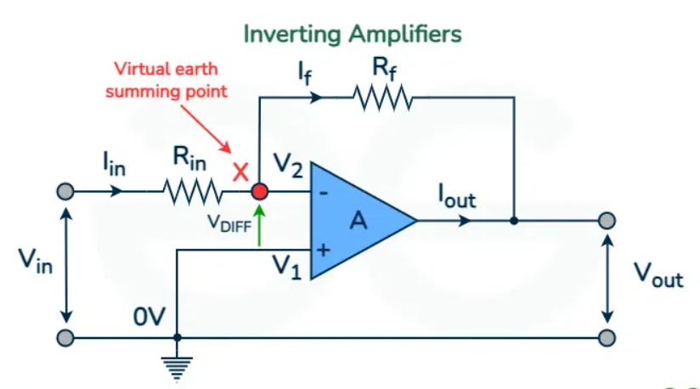

Here,
Input voltage = $V_{in}$
Output voltage = $V_{out}$
Input resistor = $R_{in}$
Feedback Resistor = $R_{f}$

In this configuration, the op-amp operates in a closed-loop mode due to the feedback connection. When analyzing inverting amplifiers, two key ideal assumptions are often made: no current flows into the op-amp’s input terminals, and the voltage at both input terminals is equal $\left(V_{1}=V_{2}\right)$. While these rules are fundamental for circuit analysis and design, real-world op-amps don't follow them perfectly, resulting in minor deviations from ideal behavior.
Applying KCL at node,

$$I_{in}-I_{f}=0$$
⸫ $I_{in}=I_{f}$

Applying KVL,

$${-V}_{in}+I_{in}R_{in}+I_{f}R_{f}+V_{out}=0$$
Or, ${-V}_{in}+I_{in}R_{in}+I_{in}R_{f}+V_{out}=0$
Or, ${-V}_{in}+\frac{V_{in}}{R_{in}}R_{in}+\frac{V_{in}}{R_{in}}R_{f}+V_{out}=0$
Or, ${-V}_{in}+V_{in}+\frac{R_{f}}{R_{in}}V_{in}+V_{out}=0$
Or, $\frac{R_{f}}{R_{in}}V_{in}=V_{out}$
Or, $\frac{V_{out}}{V_{in}}=-\frac{R_{f}}{R_{in}}$

⸫ Voltage Gain $A_{v}=-\frac{R_{f}}{R_{in}}=\frac{V_{out}}{V_{in}}$

Circuit Diagram
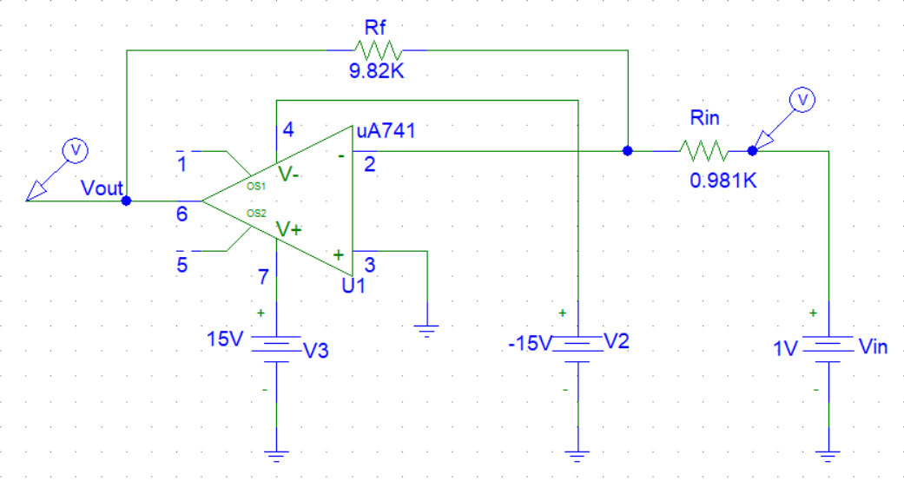

Figure-1: Inverting Amplifier Circuit

Simulation Result
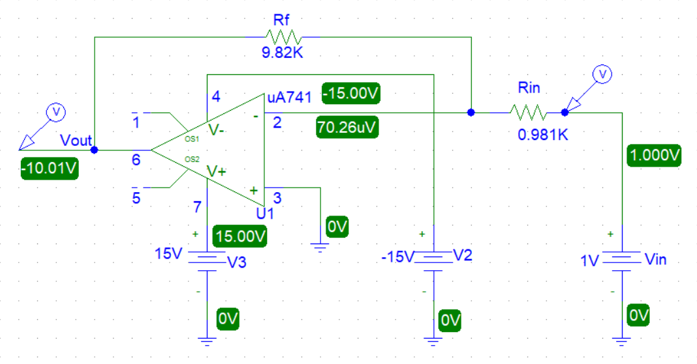

Figure-2: Simulated Inverting Amplifier Circuit
Construction
The amplifier circuit was built on a breadboard using an op-amp and precision resistors. The
resistor values measured in the lab were $R_{in}=0.981KΩ$ and $R_{f}=9.82KΩ$, which were used to set the gain. The op-amp was powered by dual DC supply, with +15V connected to pin-4 and pin-3 connected to ground through a wire. All components were connected using jumper wires and input signal was provided from a low- noise DC voltage source. A low-noise DC source was used as the input signal, and the output was measured using a digital multimeter.
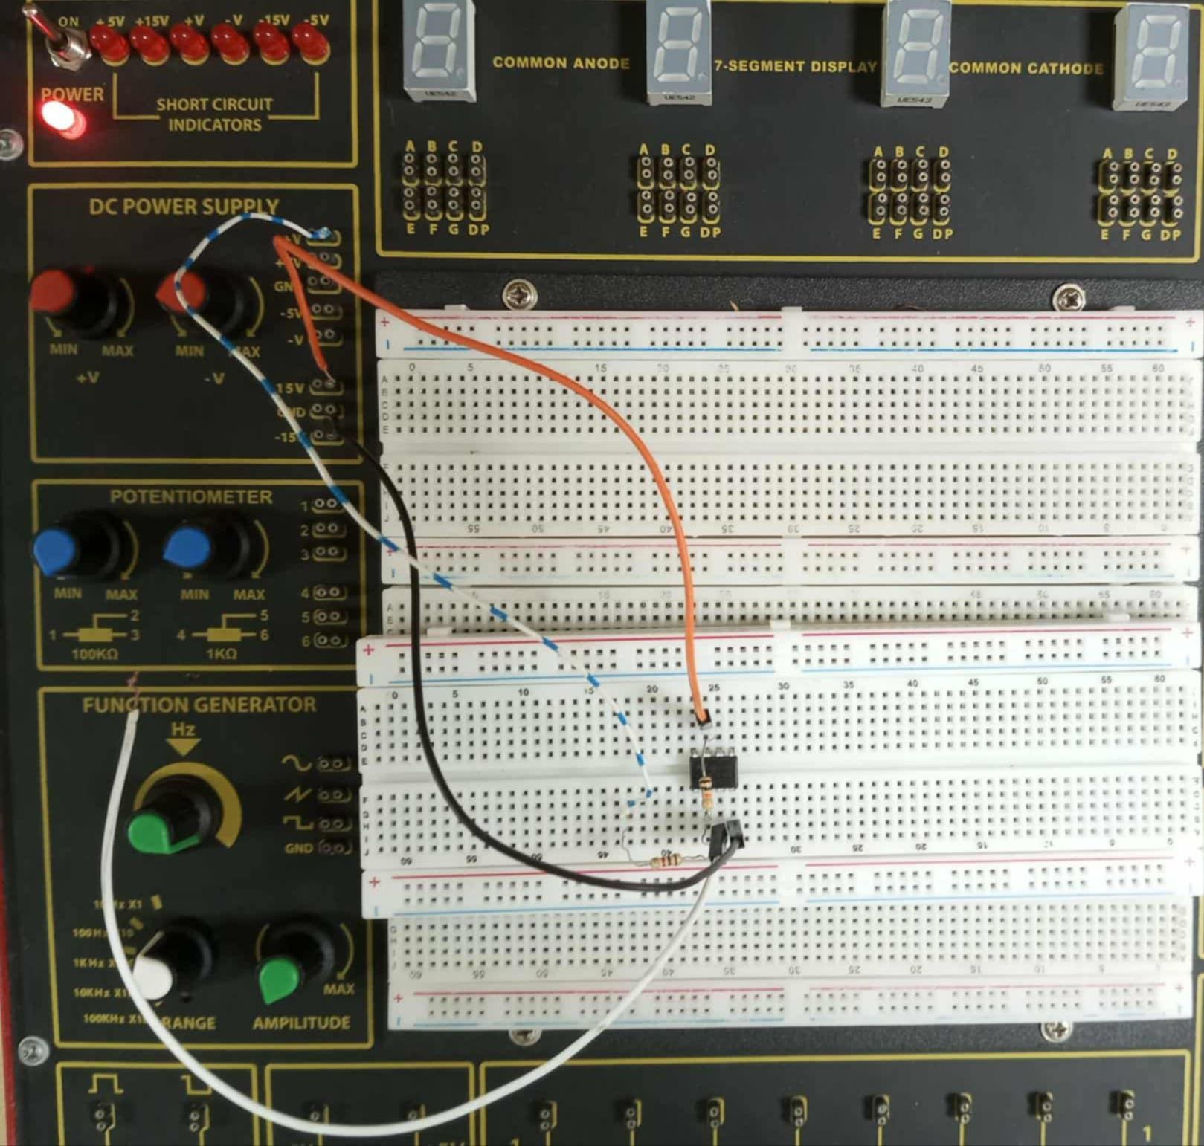

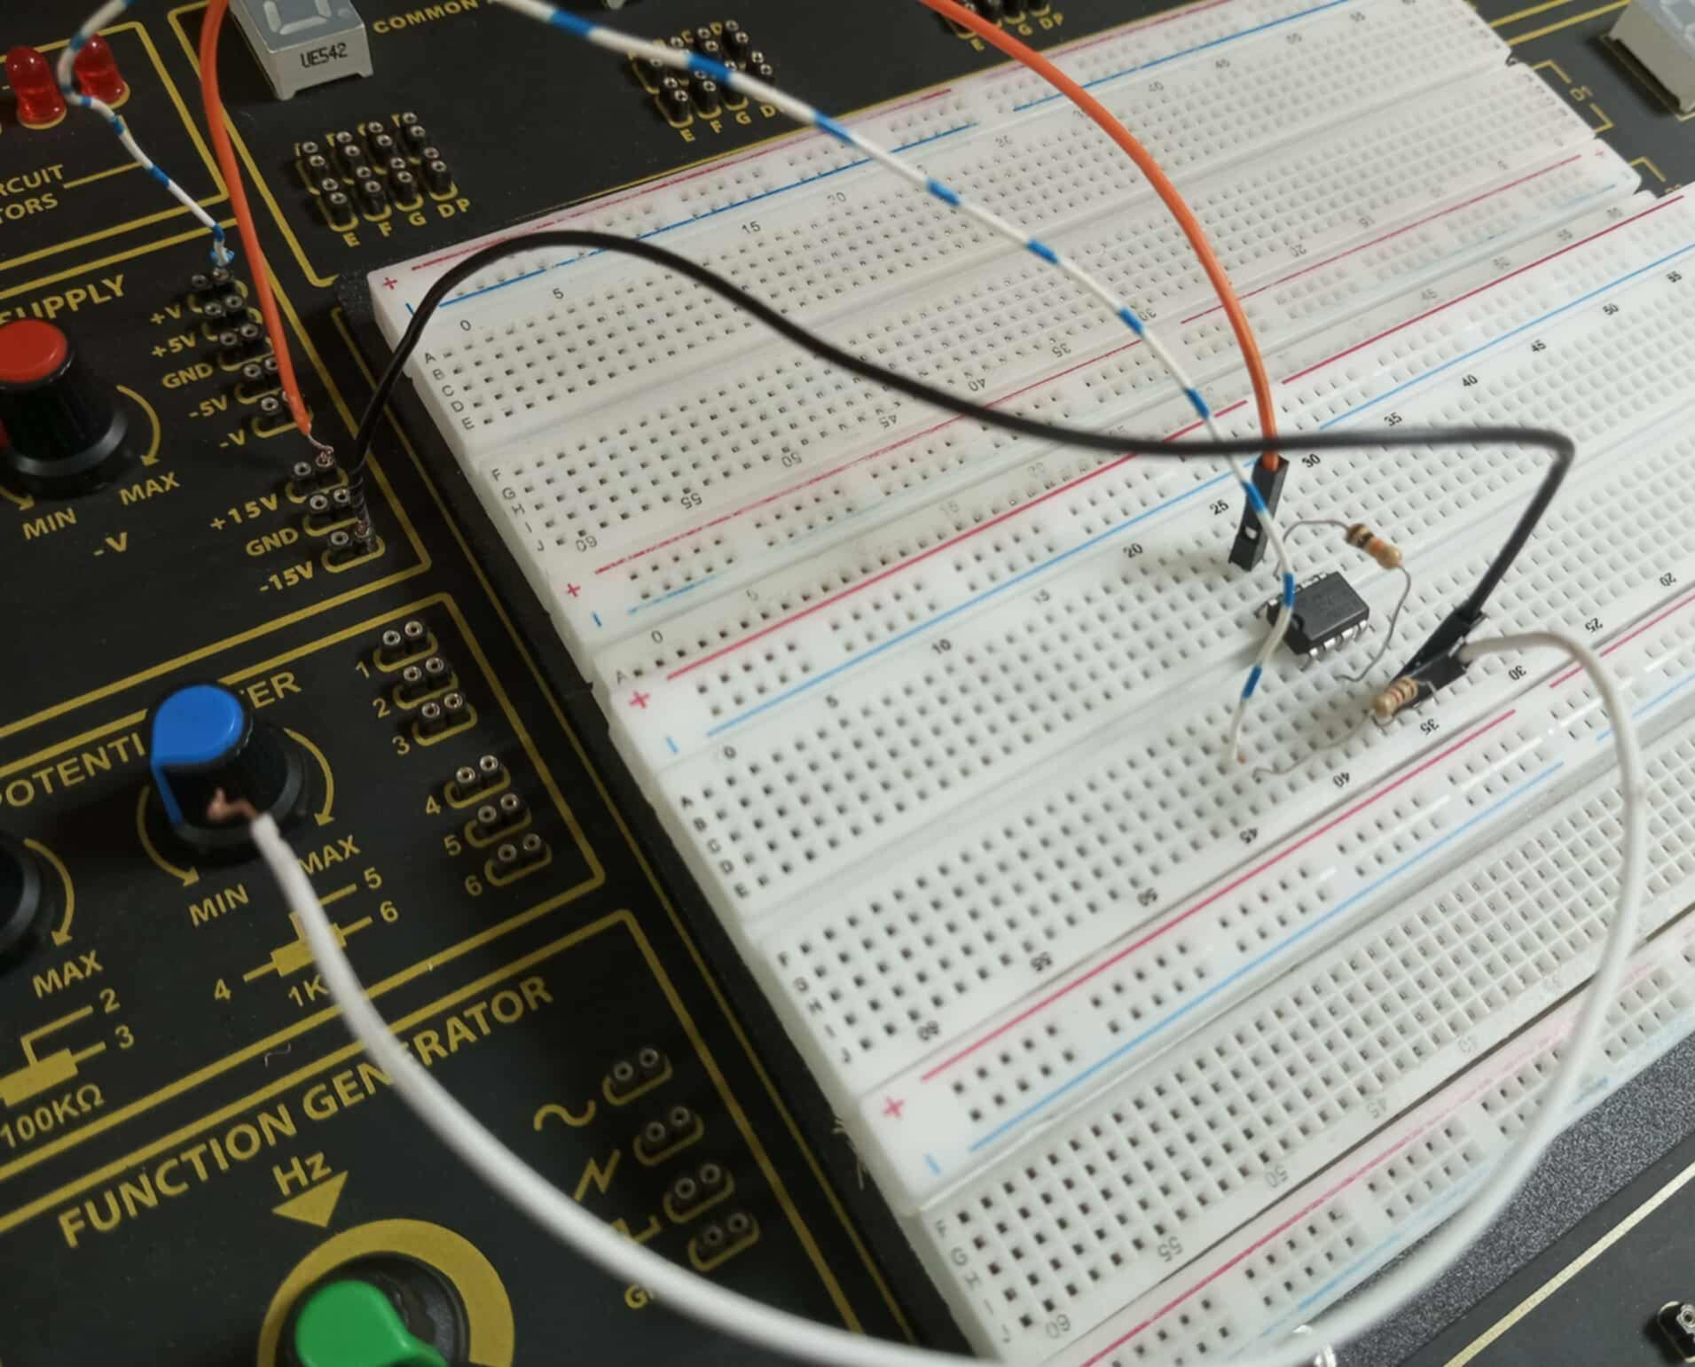

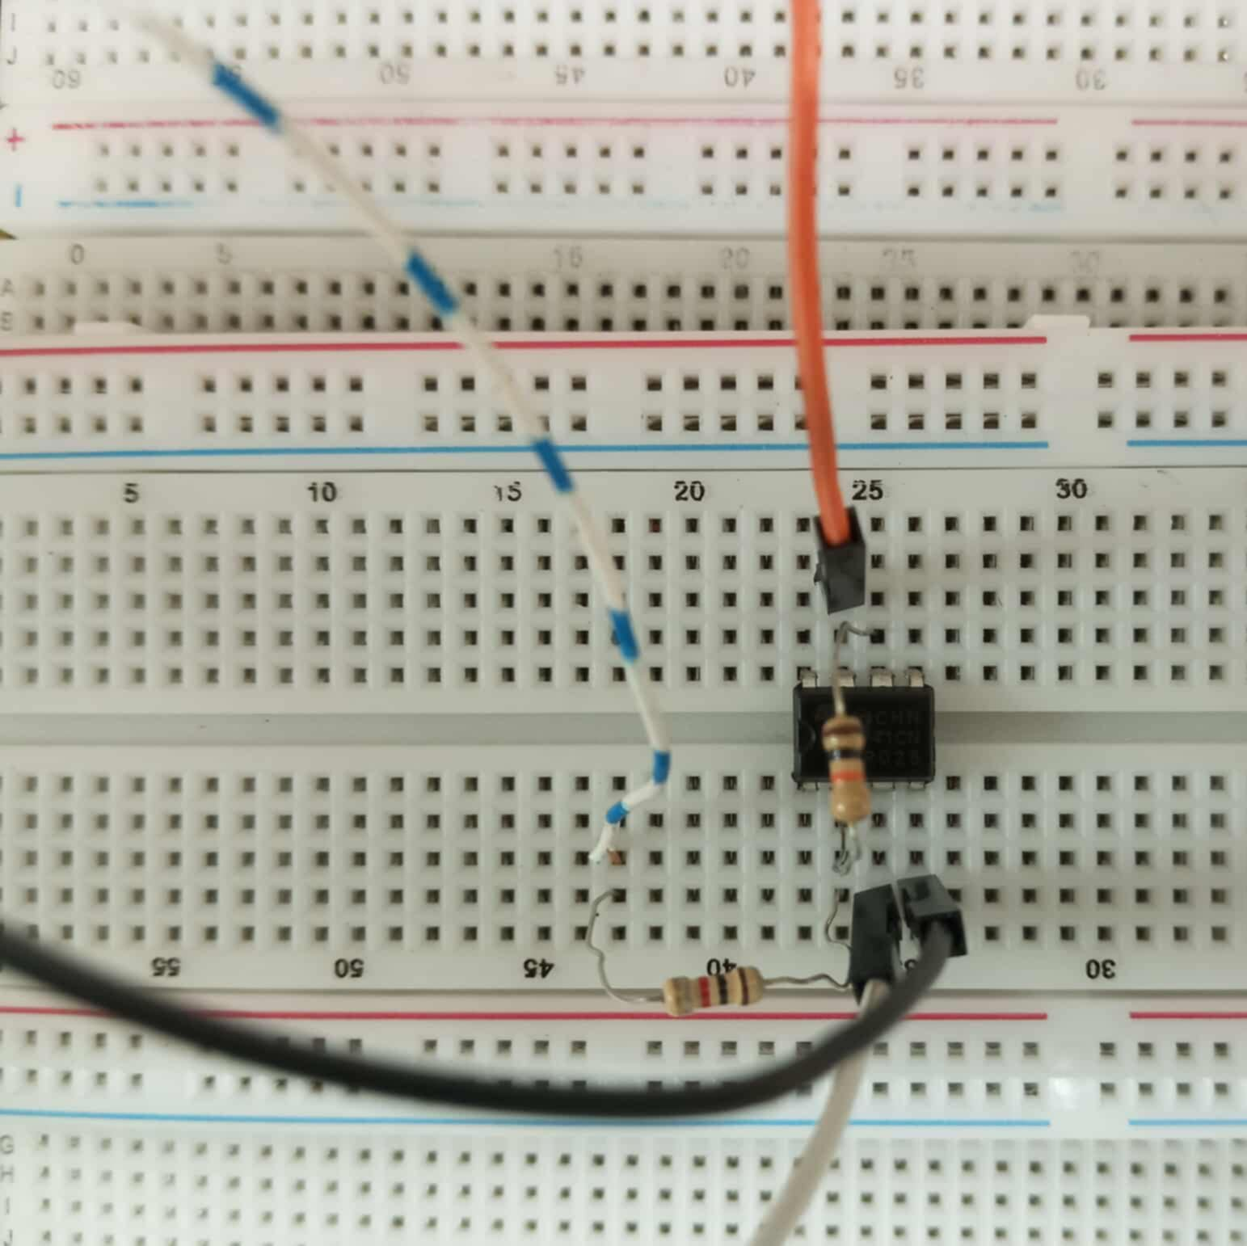

Testing
1. Set up the op-amp circuit on a breadboard, making sure everything is connected properly.
2. Connect the positive power supply to pin 7, the negative supply to pin 4, and ground pin 3.
3. Hook up a low-noise DC voltage source to the input of the circuit.
4. Start by setting the voltage source to a small positive value (like 1V), and use a digital multimeter to measure the output.
5. Slowly increase the input voltage in small steps (e.g., 0.1 V at a time) and record the output for each step.

Experimental Datasheet
Vin (input voltage) | Vout (Output Voltage)
0.0453V | -0.4653V
0.131V | -1.3V
0.4684V | -4.89V
1V | -10.01V
Analysis
Theoretical Gain,
$R_{in}=1KΩ$ , $R_{f}=10KΩ$, $V_{in}=1V$
From the theory,
Voltage Gain $A_{v}=-\frac{R_{f}}{R_{in}}=-\frac{10}{1}=-10$
Again,
$$A_{v}=\frac{V_{out}}{V_{in}}$$
Or, $V_{out}=A_{v}×V_{in}=-10×1=-10V$

Using this same method,
for $V_{in}=0.0453$ $V_{out}=A_{v}×V_{in}=-10×0.0453=-0.453V$
for $V_{in}=0.131v$ $V_{out}=A_{v}×V_{in}=-10×0.131=-1.31 V$
and for $V_{in}=0.4684v$ $V_{out}=A_{v}×V_{in}=-10×0.4684=-4.684 V$

Measured Gain,
$R_{in}=0.981KΩ$ , $R_{f}=9.82KΩ$, $V_{in}=1V$
From the theory,
Voltage Gain $A_{v}=-\frac{R_{f}}{R_{in}}=-\frac{9.82}{0.981}=-10.01$

Again,
$$A_{v}=\frac{V_{out}}{V_{in}}$$
Or, $V_{out}=A_{v}×V_{in}=-10.01×1=-10.01V$

Using this same method,
for $V_{in}=0.0453$ $V_{out}=A_{v}×V_{in}=-10×0.0453=-0.453V$

$$Error=\frac{\left|\left(Theoretical value-measured value\right)\right|}{Theoretical value}×100\%$$
⸫ $Voltage Gain Error=\frac{|\{-10-(-10.01)\}|}{-10}×100\%=0.1\%$
⸫ $Outout Voltage Error=\frac{|\{-10-(-10.01)\}|}{-10}×100\%=0.1\%$
Comparison between theoretical value and measured value
 | Theoretical value | Measured value | Error
Voltage Gain, $A_{v}$ | -10V | -10.01V | 0.1%
Output Voltage, Vout | -10V | -10.01V | 0.1%
 | -0.453V | -0.4653V | 2.715%
 | -1.31V | -1.3V | 0.763%
 | -4.684V | -4.89V | 4.4%
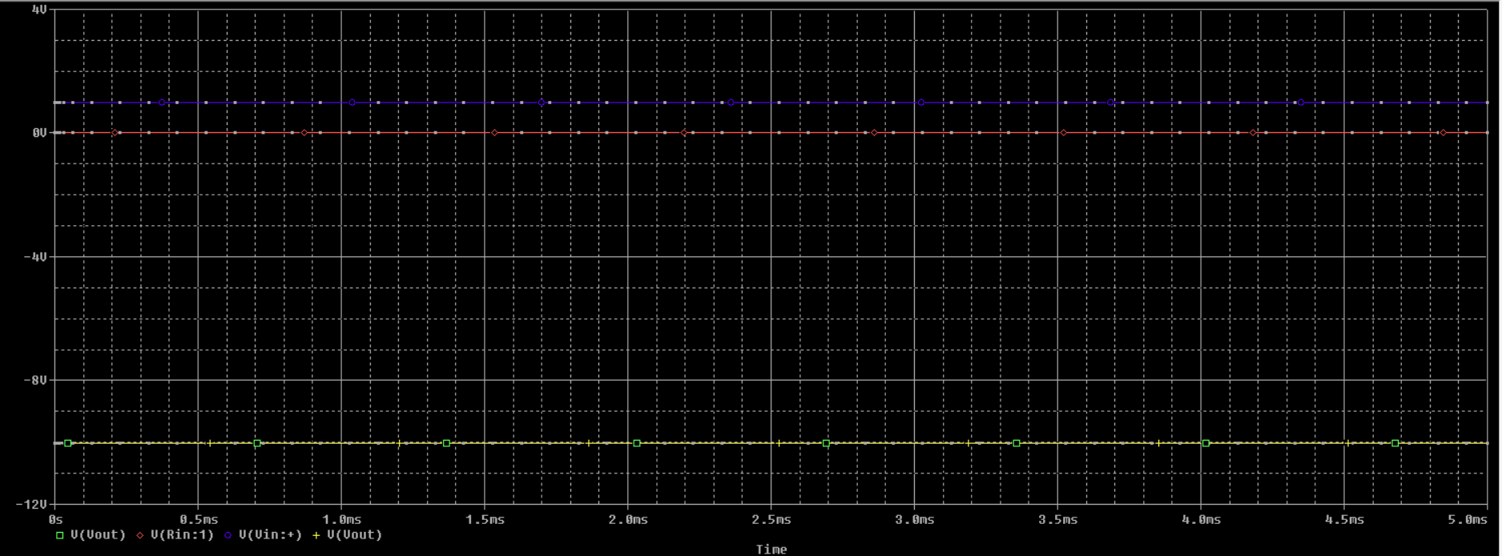

Figure-3: Input and Output Voltage Waveform

This project focused on designing and constructing a precision DC voltage amplifier with a fixed gain using an operational amplifier in an inverting setup. The target gain was -10, meaning an input of 1V should ideally produce an output of -10V. After assembling and testing the circuit, the actual resistor values were $R_{in}=0.981KΩ$ and $R_{f}=9.82KΩ$, slightly different from the ideal, which led to a measured gain of -10.01 and an output of -10.01V. These results showed a gain error of 0.1% and a voltage error of 0.1%. Such deviations are typical in practical electronics due to resistor tolerances, minor measurement inaccuracies, and environmental factors like temperature or noise. Overall, the close match between the measured and theoretical values demonstrates the accuracy of the design and confirms that the amplifier performed reliably and as expected.
Discussion
For this project, we designed a circuit for a gain of 10, calculated the resistor values, and then carefully measured them before building. We constructed the circuit on a breadboard, powered it up, and then tested it by applying various input voltages and measuring the output with a multimeter. We had already calculated the theoretical values, and when we compared them to our practical results, they were a very close match. Any small errors were likely due to the resistors and measurement limitations. We also simulated the circuit, and it confirmed our design was correct. The whole process of designing, building, and testing was a success, and we gained some great practical experience.

Conclusion
The project successfully designed and built a precise DC voltage amplifier using an op-amp. Simulations and measured values in the project experiment confirmed its accuracy and stability, with minimal error between expected theoretical and measured results.

Applications of the Precision DC Voltage Amplifier
Precision DC voltage amplifiers are incredibly useful in electronics, especially when you need to amplify small signals with high accuracy.
1. Sensor Signal Conditioning: They're used to amplify tiny signals from sensors like those for temperature or pressure, ensuring accurate data without adding noise.
2. Medical Instruments: Devices like ECGs and EEGs rely on these amplifiers to measure the very low-level electrical signals from the human body.
3. Data Acquisition: In labs and factories, they amplify signals before they get converted for digital processing.
4. Test Equipment: Multimeters and oscilloscopes use them to get more accurate voltage readings.
5. Control Systems: They're essential for reliable amplification of small signals in automation and control systems.

